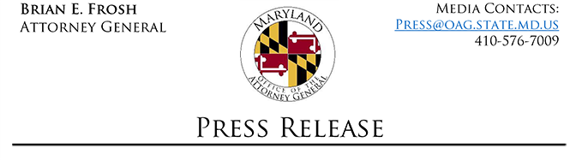

Prince George’s County Professional Counselor Pleads Guilty to Felony Medicaid Fraud
Baltimore, MD (July 23, 2019) - Maryland Attorney General Brian E. Frosh announced today that Adahlia Marye Glover, 42, of Laurel, pleaded guilty to one count of felony Medicaid Fraud for submitting claims that caused the Maryland Medical Assistance Program (Medicaid) to reimburse Glover more than $36,000 for services that she did not provide.
Anne Arundel County Circuit Court Judge Ronald A. Silkworth sentenced Glover to probation before judgment; placed Glover on five years of supervised probation; ordered 50 hours of community service at Arundel Neighborhood; and ordered and suspended a fine of $10,000. Judge Silkworth also ordered Glover to pay restitution to Medicaid in the amount of $36,576.02. As a condition of Glover’s probation, Glover is required to withdraw as a Medicaid provider and not reapply for a period of five years. Glover is also prohibited from working for any provider in a federally-funded health care program for five years.
Glover is a licensed clinical professional counselor who operated a private mental health practice. From September 2015 through November 2017, Glover submitted false claims in connection with her private mental health practice. Specifically, Glover submitted claims to Medicaid and was reimbursed for services that she did not provide to her clients because she was out of the State of Maryland.
In making today’s announcement, Attorney General Frosh thanked the Medicaid Fraud Control Unit, specifically Assistant Attorney General Tracee Orlove Fruman, Investigator Michael Glenn, and Investigator Julia Foster Tansmore. Attorney General Frosh also thanked the Maryland Department of Health, Office of Inspector General for its assistance.

